

TravelBuddy

By: Arpit Shah and Shishir Bijalwan



April 3, 2017

Android Project

Syracuse University

**Application flow**

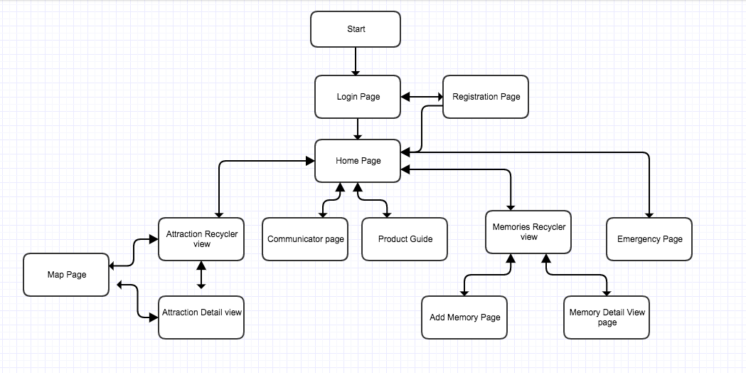

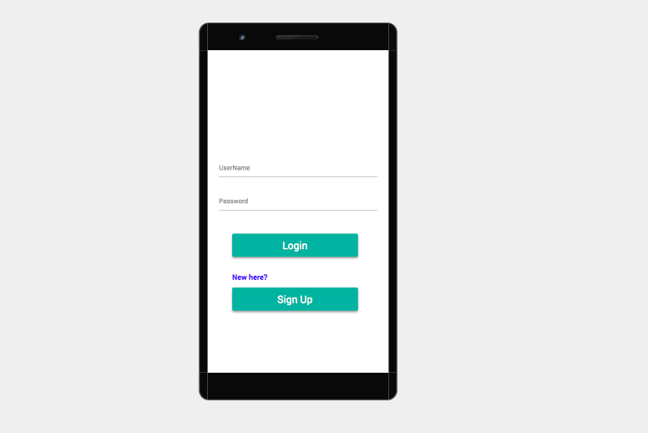

Login Page

Description:

This is the first page that will pop up when user click on our application. Here the user has two options either to create a new account if using for first time or login if existing user.

Interactions:

1. Login button: On click of login button if the credential is correct user will go to homepage of app
2. Sign Up button: On click of sign up button the user will be taken to registration page.

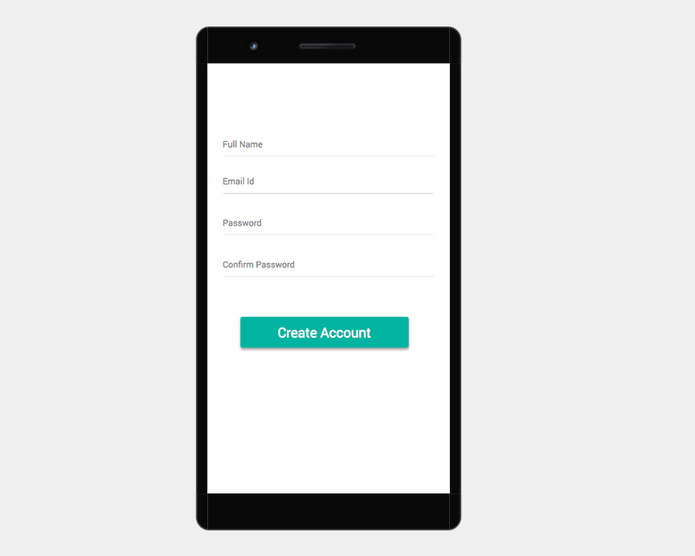

Registration Page

Description:

This page is for the users who are using the application for the first time. We take some personal information as input in this page to set up an account.

Interactions:

1. Create Account: On click of this button if the email id is not registered already the user will be taken to application home page. If not will be asked to use another email id.

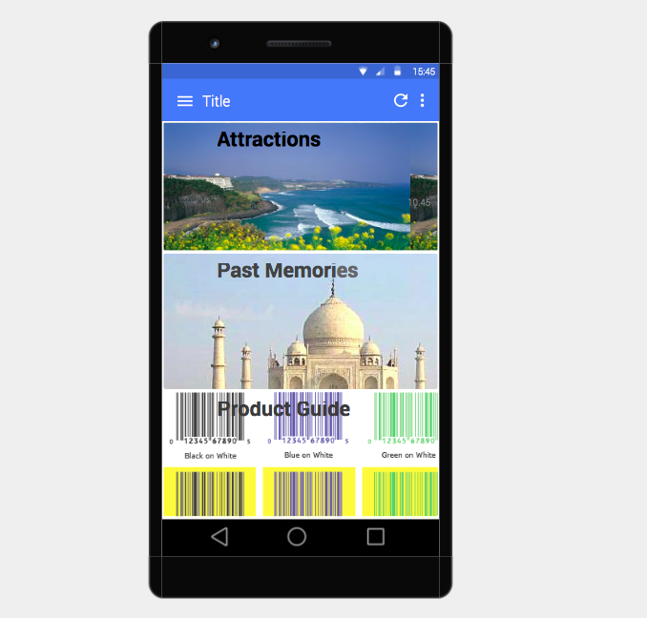

Home Page

Description:

This the main page of our application. From here he can use any facility available in the application. We have given three shortcuts to three activities which will be used most frequently. Rest of the activities including these can be reached using shortcut in drawer.

Interactions:

1. Attractions: On click of this button the user will be taken to the attraction recycler view.
2. Past Memories: On click of this button the user will be taken to the Past memories recycler view.
3. Product Guide: On click of this button user will be taken to Bar code reader product guide.

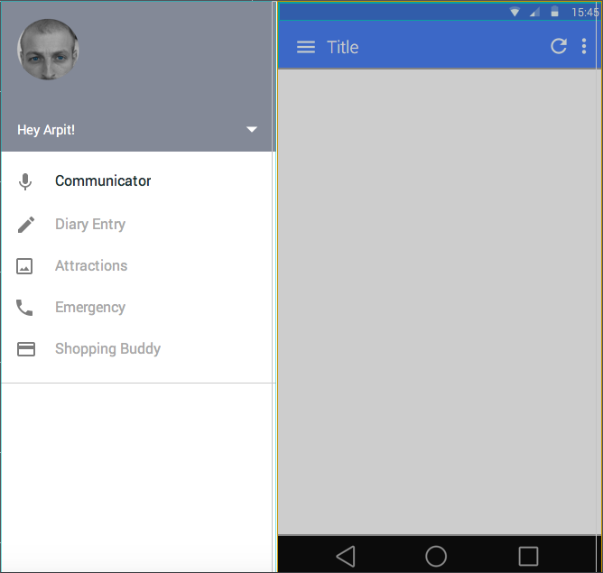

Drawer

Description:

In the drawer we have provided the facility to click on the links to use different features

Interactions:

1. Attractions: On click of this button the user will be taken to the attraction recycler view.
2. Diary entry: On click of this button the user will be taken to the Past memories recycler view.
3. Shopping Buddy: On click of this button user will be taken to Bar code reader product guide.
4. Communicator: This will take use to voice translator page.
5. Emergency: This will take us to the page to call emergency numbers

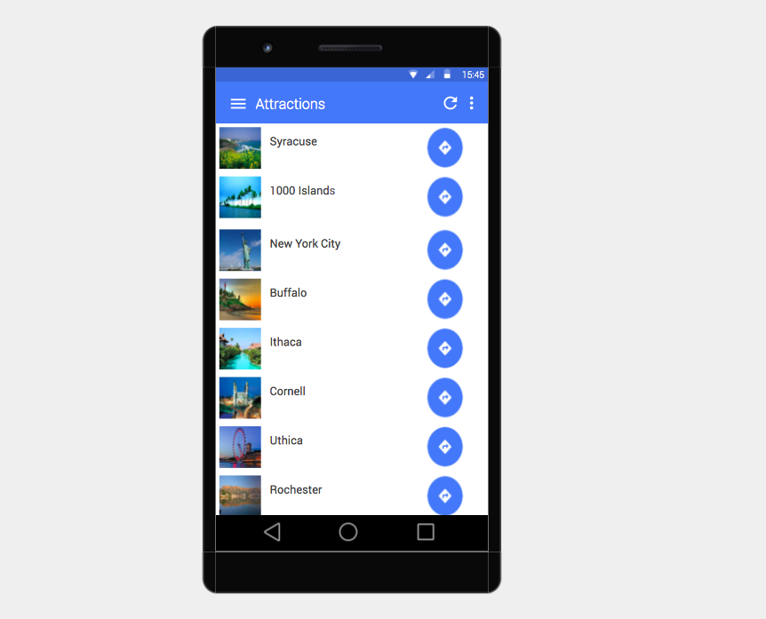

Attraction Recycler view

Description:

This is the recycler view for attractions. Each card will have a photo of the place the name of the place and a button to get the directions to reach there using google maps

Interactions:

1. Card view: When the user clicks on any of the card he will be taken to the detail view of it.
2. Direction button: On click of this image button the user will be taken to the google map page for directions

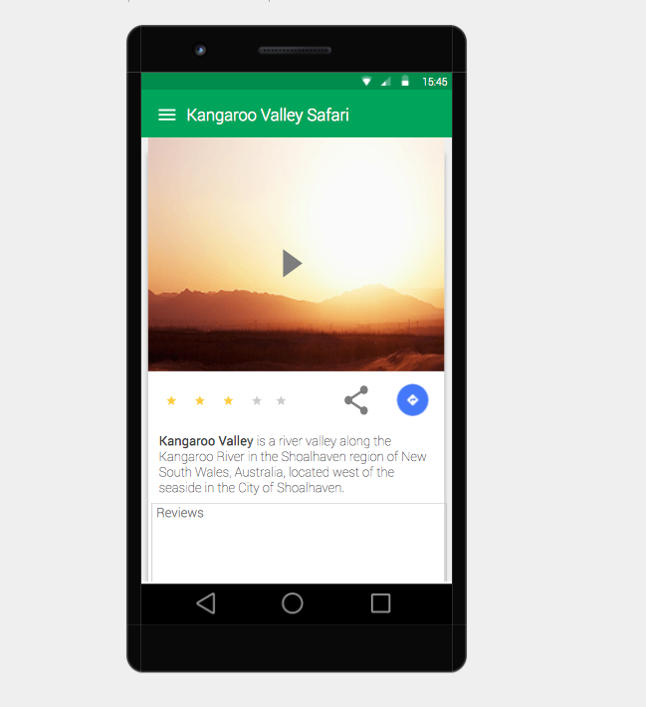

Attraction Detail view

Description:

This is the detail view of the attractions. It has the YouTube view giving information about the place. Reviews from the users and the share options

Interactions:

1. Direction button: On click of this image button the user will be taken to the google map page for directions
2. Video click: On click of the video the video with information about the page will be displayed.
3. Share: On click of the share button user could share the information about place with others

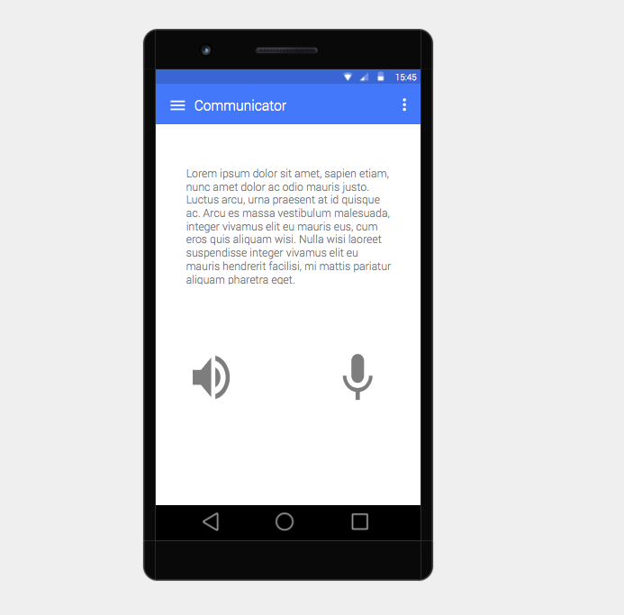

Communicator page

Description:

This page is for language translation. It allows user to change language to local language. Once the user has done with speaking after clicking mike. The text will be automatically converted to local language

Interactions:

1. Mike: On click of the mike button user will speak what he wants to get translated.
2. speaker: On click of the speaker button the translated text will be spoken on speaker

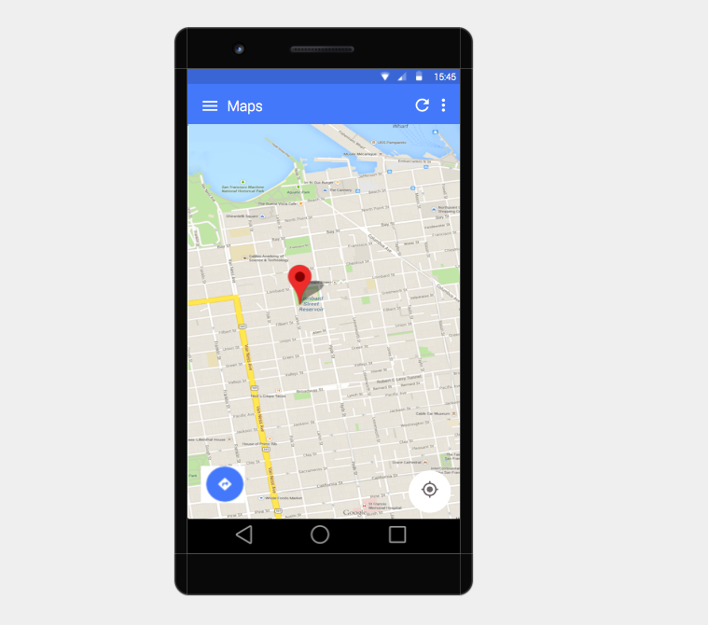

Map Page

Description:

This is the google map page to help the user get the directions to a location

Interactions:

1. Direction: On click of direction arrow user can start navigations

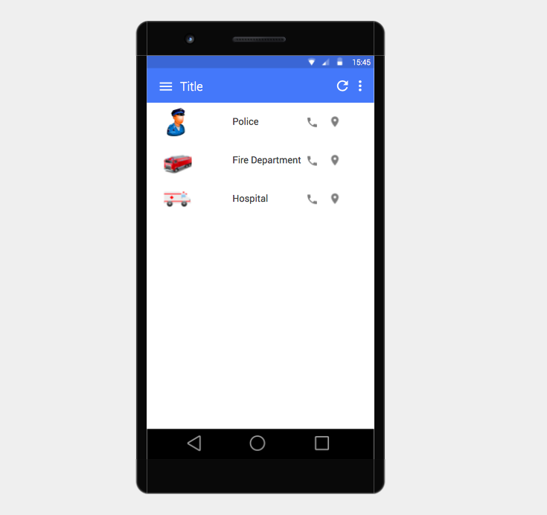

Emergency Page

Description:

This page has been created with a tourist travelling to a foreign nation and does not have emergency number of that country.

Interactions:

1. Police Button: To call police for assistance
2. Fire department: To call fire department
3. Hospital: To call hospital emergency number

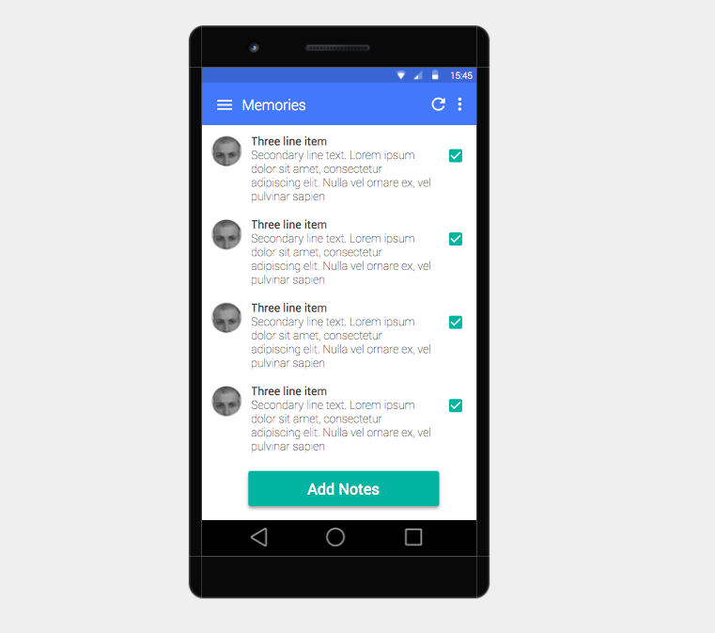

Memories Recycler view

Description:

This page id the center point where user get access to his old memories (Diary entries) and option to create new

Interactions:

1. Card View: The user could go to the detailed view of each memory
2. Add Notes: Will take user to create new diary entry page.

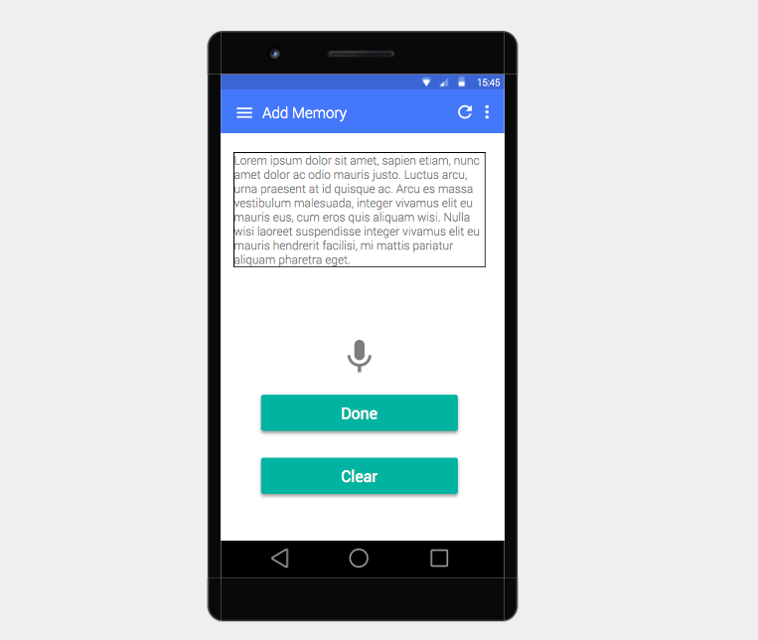

Add Memory Page

Description:

This page is for the user to create a new diary entry while he is travelling. So he can relive those moments again.

Interactions:

1. Mike: On click of mile button the user can start speaking and the it will get noted and displayed in the text box.
2. Clear: To clear the text box.
3. Done: To add a new diary entry

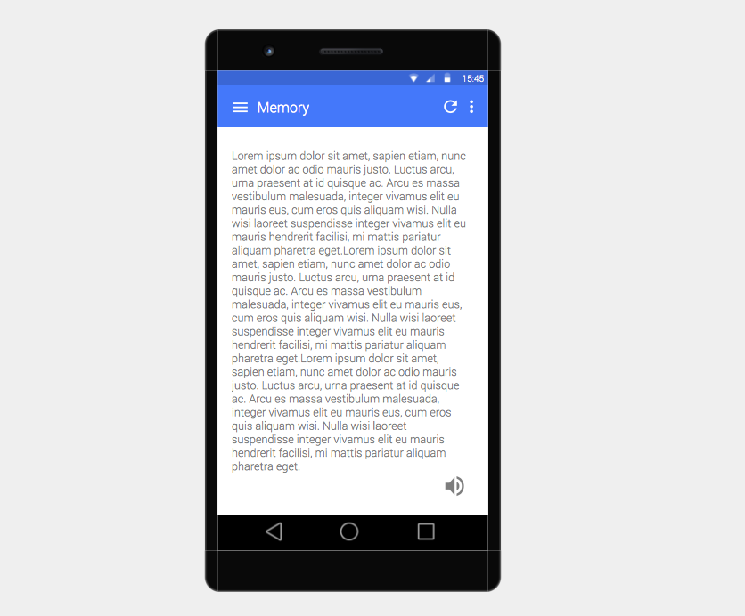

Memory Detail View page

Description:

This page displays some old memory text you did create earlier.

Interactions:

1. Speaker: On click of speaker button the user can listen the whole text

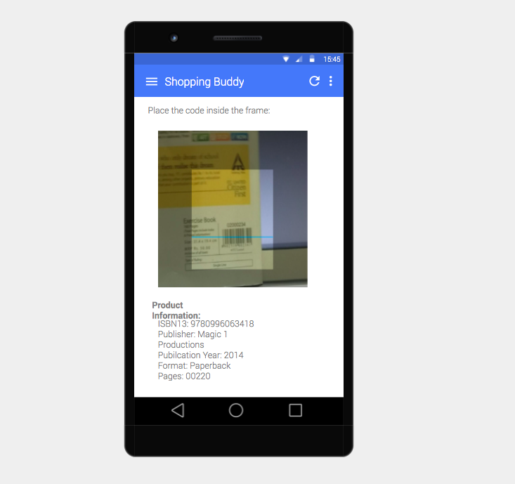

Product Guide

Description:

This page has been developed keeping in mind that the user might not know the local language so won’t be able to read what information is mention on products. So with this user will able to read the bar code and we will provide him the product info.

Interactions:

1. Bring the bar code scan in the middle of the screen camera.